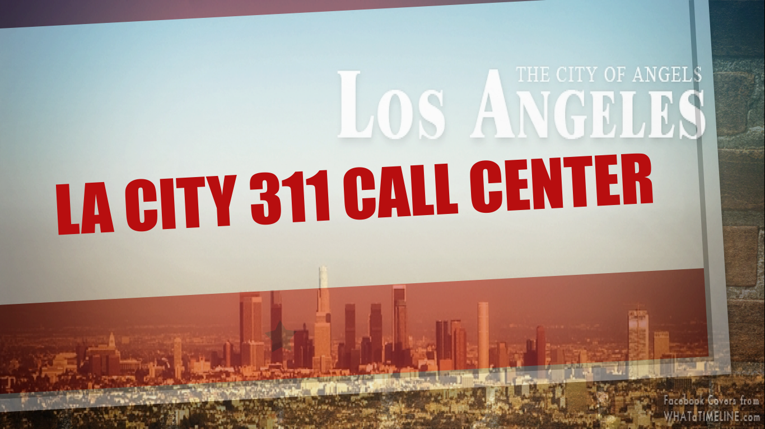

Operation Analytics of LA City 311 Call Center

USC Marshall Business School

DSO 545 Statistical Computing and Data Visualization

Group 10  
Lulu Zhang, Lacy Yuan, Yung-Wen (Emily) Liu, Clayton Tran

Table of Contents

**Introduction** 3

**Data Description** 3

**Methodology** 4

**Summary of Findings** 5

**Seasonality and Peaks to meet demand of service requests** 5

**Homeless Crisis** 6

**Focus** 7

**Bulky Items** 7

**Homeless Encampment** 11

**Appendix** 14

**Data Overview** 14

***Request Type, Frequency vs Average Processing Hours*** 14

***Request Source, Frequency vs Average Processing Hours*** 15

***Request by Departments, Frequency*** 17

***Geographical Breakdown*** 19

***Mobile App vs Phone Call*** 21

***Other Graphs*** 23

# **Introduction**

Users of the City of Los Angeles’s 311 system can request services ranging from removing bulky items to fixing streetlights. The frequency and various types of requests are indicative of the needs of Los Angeles’s people of the cities services.

Los Angeles is most known for not only its vast sprawl but also for its ethnic enclaves, diverse communities, and never ending traffic. Because of this sprawl and diversity, the City of Los Angeles could find great use in identifying and analyzing various trends in its 311 system to uncover distinct patterns of user behavior to predict future demands or identify current shortcomings and prevent them from happening.

We want to investigate if the provided data can answer the following two questions:

Are there seasonality or peaks in certain service requests, and if so, is the city meeting these demands effectively? Are these issues distributed throughout the Los Angeles sprawl or is it centrated in a particular location?

Homelessness is at a crisis point in Los Angeles, but is this pervading issue a centralized one or existent throughout the city. If so, how well is the city of Los Angeles responding to requests of homeless encampment?

# **Data Description**

The data used for this analysis is the call center data for 311

* **Time Duration**  
  We select time period from Dec 2015 to Nov 2016 and subset the dataset into 855837 observations with 33 variables. In this way, we can have the most updated data point and also be able not to overlap month.
* **Variables**  
  1. Latitude, Latitude, zip code of each request  
  2. RequestSource(16 levels):  
  -Call, Council's Office, Driver Self Report, Email, Fax, Letter, Mayor's Office, MobileApp, QueueInitiatedCustomerCall, Radio, SelfService, TDD/NexTalk, Twitter, Voicemail, Walk-in, WebForm  
  3. RequestType(12 levels):  
  -BulkyItems, Dead Animal Removal, Electronic Waste, Feedback, Graffiti Removal, Homeless Encampment, Illegal Dumping Pickup, Metal/Household Appliances, MultipleStreetlightIssue, Other, ReportWaterWaste, Single Streetlight Issue  
  4. Owne (7 levels) :  
  -BOE,BOS,BSL,BSS,ITA,LADWP,OCB  
  5. ActionTaken (9 levels): we only kept datapoints that is marked as “SRCreated”, which is solved records.  
  -Escalateto Supervisor, Information Provided, Long Distance Call Support, Referred to Other Agency, SR Created, SR Updated, Status Provided, Transferred, Unable to Assist  
  6. Status(6 levels): we only used datapoints that is marked as “Closed.”  
  -Cancelled, Closed, Forward, Open, Pending, ReferredOut  
  7. MobileOS(2 levels)   
  -iOS, Android  
  8.Police Precinct(22 levels):  
   -77TH STREET, CENTRAL, DEVONSHIRE, FOOTHILL, HARBOR, HOLLENBECK, HOLLYWOOD, MISSION, NEWTON, NORTH HOLLYWOOD, NORTHEAST, OLYMPIC, PACIFIC, RAMPART, SOUTHEAST, SOUTHWEST, TOPANGA, VAN NUYS, WEST LOS ANGELES, WEST VALLEY, WILSHIRE.
* **Created Variables**  
  1. Processing time (ProcessHours = UpdatedDate - CreatedDate) is a crucial metric to measure how effective the city is not only responding but also completing the service requests in a timely manner. We will use this along with frequency of service requests to assess the city’s performance with 311 requests.  
  2. Month  
  3. Day of the Week  
  4. Hour of the Day  
  5. Precinct Region : "Central" "West" "Valley", “South”,”Other”. According to the data from LA county’s police Precinct, we use Police Precinct variable as key factor to divide the region.
* **Frequency**: the total amount of service requested
* **Successful Rate**: we define it as serviced successfully delivered. Filter the dataset with status equals to closed and actiontaken equals to SR Created.

# **Methodology**

We used R studio to perform the data analysis and visualization.

1. Use dplyr and lubridate to clean and manipulate the data
2. Use ggplot2 and ggmap to visualize the cleaned data
3. Compared different graphs based on same x and y aeix to generate insights
4. Insights on root cause and give potential recommendations

# **Summary of Findings**

## **Seasonality and Peaks to meet demand of service requests**

We initially looked at the key contributor to 311 calls, which was Bulk Item Requests. This comprised of nearly 44% of the dataset and nearly 1.5x the next largest category - Graffiti Removal. This large proportion speaks to what Los Angeles inhabitants use 311 for - to inform the city to clean up and dispose items from their immediate area. As such, we thought it was prudent to investigate any trends on seasonality, assess the city’s performance, and pinpoint which regions may be most affected by this request.

In investigating the month over month demand, the peak month was August with incremental growth month over month since January. Shortly after there is a sharp decline in the following months to beneath the previous lowest demand in January. We assume that this could be highly seasonal as people are likely to move around the annual school schedule such as moving to a new primary/secondary school or most likely due to the start of college or moving closer for work.

We then dug deep into the month over month trend in processing time and surprisingly we encountered an unexpected trend. There seems to be very little correlation to the number of requests with the processing time. We had expected either processing time to increase as the number of requests increase, which would explain a potential ceiling effect based on staffing and resources, or processing time to flat line which would indicate despite the number of requests the city of LA would be processing requests in time and thus fully optimized. Perhaps, the city of LA has had noticed a seasonal pattern with the number of request and have enacted some external policies or business actions to counteract any uptick in demand.

It is difficult to fully stand behind if the city of LA is doing well without a clear benchmark. A highly valuable comparison would be to relate this metric with any consumer satisfaction surveys. Although it seems processing time for bulk items is within average of the other processing time, customers may be especially impatient to get bulk items out of their vicinity as soon as possible.

We looked into the any regional differences for bulky items and saw requests were largely spread out across the Los Angeles area including Long Beach/South Bay and the Valley. As shown in the previous analysis, the processing time had a wide range regardless of location.

In comparing the regions based on police precinct, there was a surprising number of requests in the Valley region, while average processing time by region was more or less the same. This consistency is highly valued, but as previously stated, we are unaware if this process time is considered a “good” mark or even a “satisfactory” mark based on consumer perception. With a seasonal demand and its high proportion relative to other types of requests, it can be assumed that consumers are relying heavily on 311 for Bulk Item removal and the City of LA is delivering on those demands.

## **Homeless Crisis**

The homeless issue has reached a crisis stage for the city of Los Angeles. In looking at the dataset and finding that the average processing time is among the highest among service types, we felt it was prudent to investigate further to see if the city of LA was improving on this important issue. These requests most importantly reflect the inhabitants of LA’s attitude toward the homeless, such that they would be quick to report especially if there are acts of endangerment or sanitary issues in the immediate area. Furthermore, the outward appearance of homeless encampments is to some a shock or even an eyesore. Even further, some would say that living in Los Angeles may not be desirable or attractive because of the presence of the homeless. As a result investigating this further may reveal insights on how inhabitants of LA view their immediate surroundings as well as their attitudes about the homeless.

In looking at the trend line between process time and month to month demands, we find that process time is actually declining with respect to the increasing number of reports. This is both good news but also alarming. Good news that the city of Los Angeles is acting readily and improving on each month to respond to these requests, but alarming because the inhabitants of LA are either finding more or more incidences of homeless encampments or are readily impatient with the processing time and repeatedly report the same incidences. This speaks to how users of 311 are largely negative about the presence of homeless around their area and are being vocal about the situation. These homeless encampments are not just an eyesore, but also a potential health risk and uncomfortable situation for some; as a result, these demand numbers indicate a very grim situation about Los Angeles.

In analyzing the region breakdown based on police precinct of homeless encampment requests, they are largely centered in Downtown Los Angeles but also surprisingly in the Valley. This finding indicates that the homeless issue is not primarily a Downtown issue but is even more widespread to capture one of the more suburban areas in Los Angeles county. In looking at the breakdown based on police precinct, Central comprising of Downtown LA was the majority followed by the Valley. Interestingly, the South had the lowest amount of requests but had as high of processing time as the West. This indicates that there may not be adequate resources to address the homeless issue for the South, and to an extent the West. The Valley despite its high frequency has very good average processing time compared to the other regions. Perhaps there are best practice that the other regions can adopt from the Valley to drive down this metric.

The upward trend of requests for homeless encampments indicates both consumer dissatisfaction about this situation as well as a precarious situation for Los Angeles. As housing becomes more unaffordable and homeless being squeezed out from areas like Skid Row, the homeless are subject to developing their own areas to live. This is a social issue and indicates the need for affordable housing or shelter to cater to the homeless. It is important to consider which of these requests are repeats or if the homeless constantly being swept are the same then is there a loophole in the system that needs to be addressed.

# **Focus**

In analyzing the data, we pinpointed two key areas of focus. Bulky items as the majority of the requests stood out as we sought to understand what the inhabitants of Los Angeles were using the 311 service for. The homeless encampment stood out for two reasons - it had the highest processing time and is a social issue that pervades Los Angeles. We opted to focus on these areas based on the drastic skew in our two key metrics - number of requests and processing time.

Additional analysis of the data is found in the Data Overview section found in the Appendix.

**Bulky Items**  
Bureau of Sanitation (BOS) handles 99.9% of Bulky Item Requests

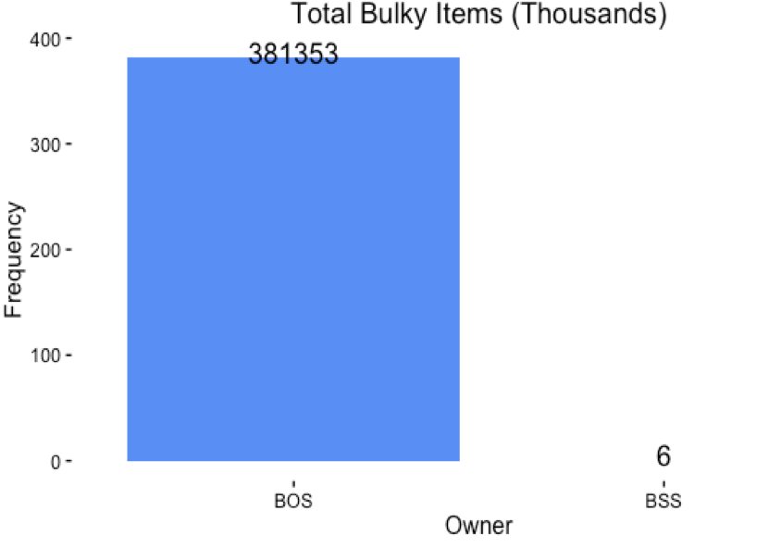

Bulky item requests hit a peak in August and declines dramatically in the following months

Potential reasons include

•Prime moving season extends from June to September

•Families moving for children’s educational reasons such as transferring to a new school or beginning college

•Big closeout sales for furniture begin in July as new styles are introduced in August

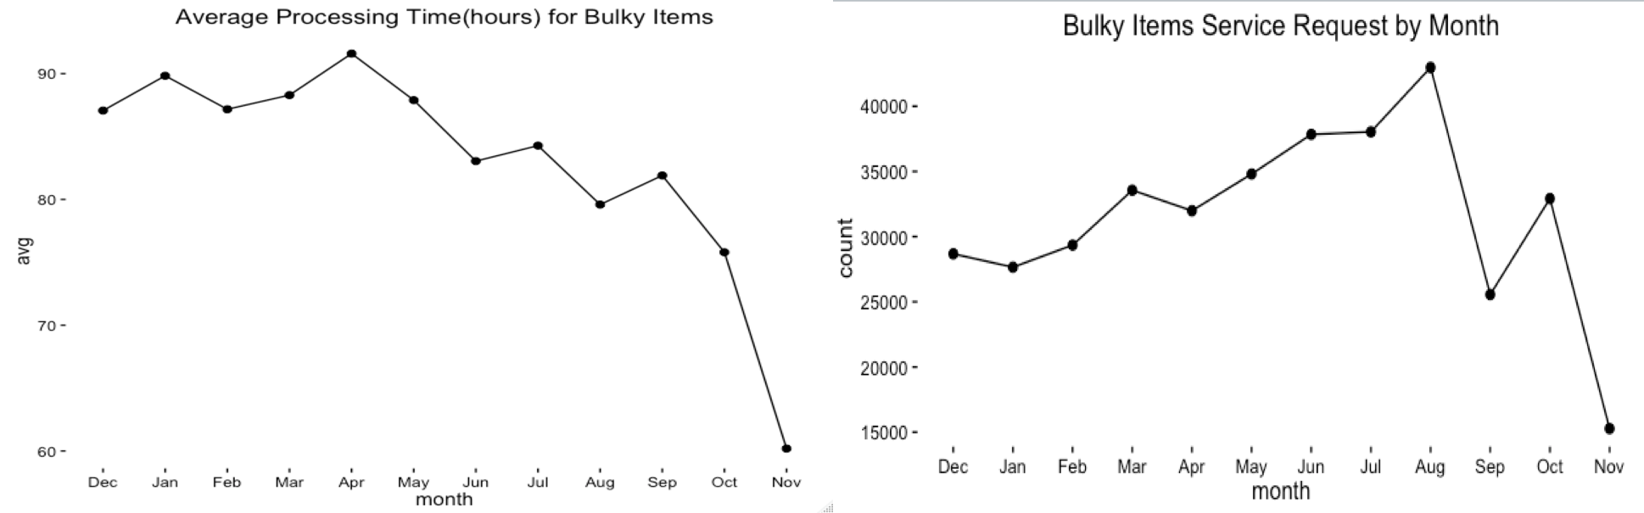

Bulky item requests range throughout Southern California

Highest Processing Time appears to be in Central LA

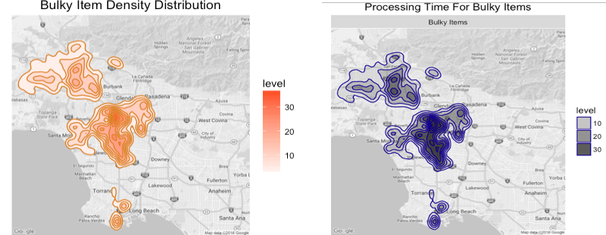

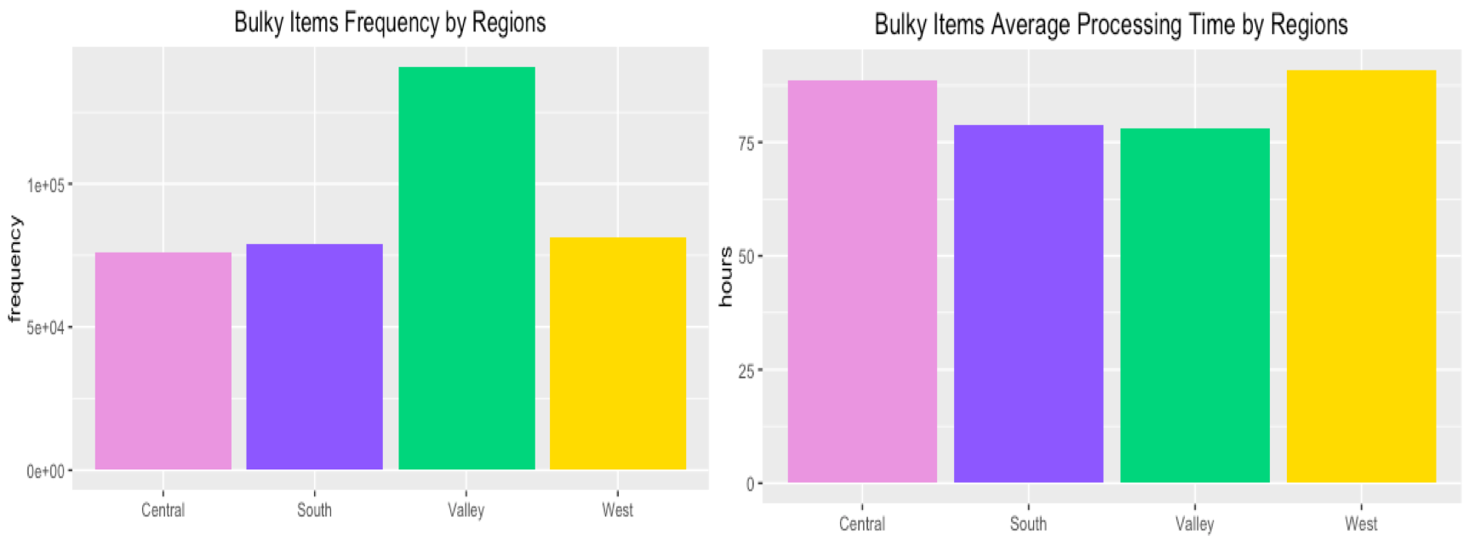

There is not too much distribution difference between months. The downtown area always needs a lot of processing time no matter which month it is. Probably because downtown area is the main area for bulky item request (see the graph below). But for the Valley region, the processing time varies from month to month. In April, May, June, July and November, longer processing time is needed in the area. 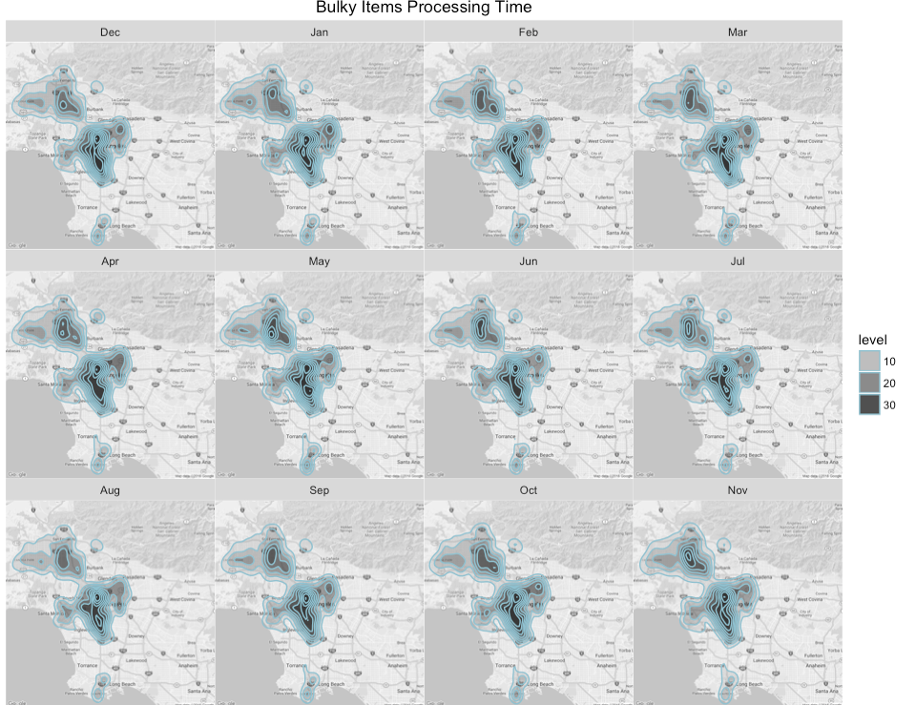

We can see that BOS’s main duty is dealing with Bulky Items requests. And from the following graph, BSS also helps handling it.

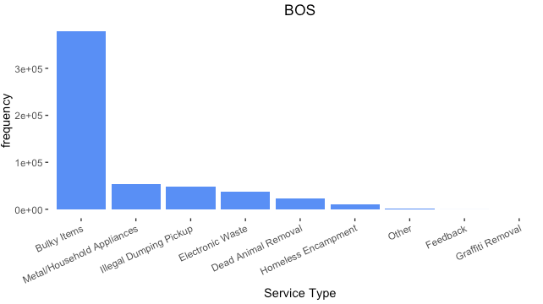

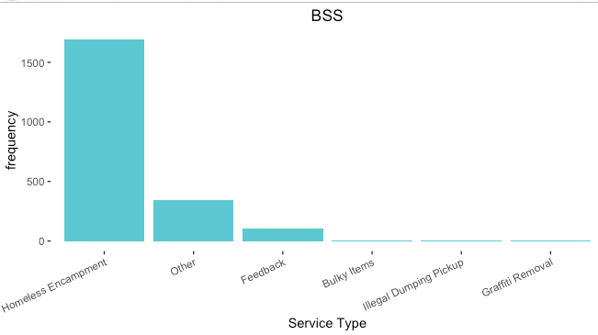

As we mentioned above, the frequency of Bulky Items request hits a peak in August. From this heatmap we can see that most requests are made on Monday at 10 a.m. and 3 p.m.

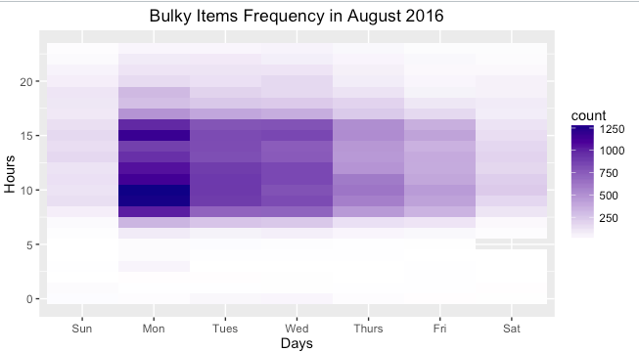

## **Homeless Encampment**

Within the blue circle is the main area that requested for Homeless Encampment service.

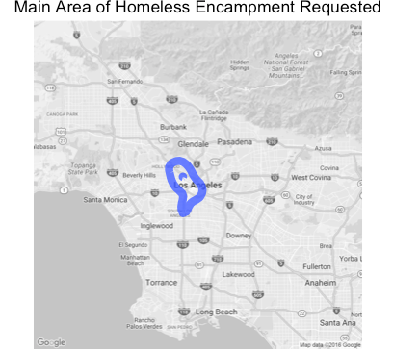

The region distribution of processing time for Homeless Encampment shares similar region distribution as the frequency one. The higher frequency area takes longer time to complete the services.

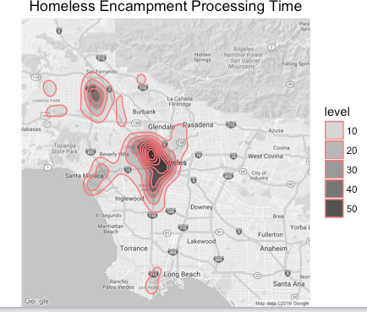

•Homeless Encampment may require the involvement of multiple parties including available social workers, security, and environmental services

Although the expectation that average processing time should either increase as frequency of requests increases or ideally stay the same despite the frequency of requests, that is not the case for this dataset Decreasing average processing time is promising but increasing frequency of requests is alarming.

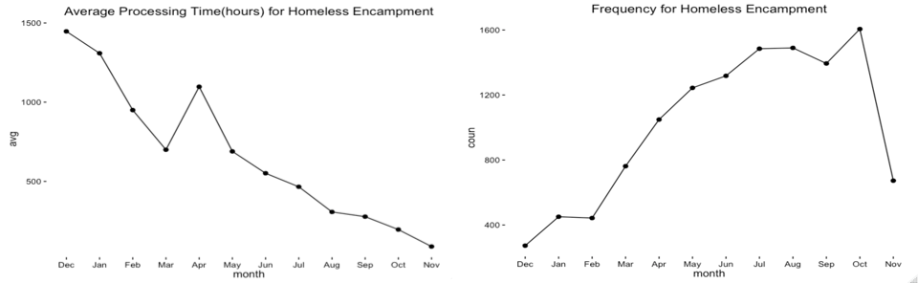

Homeless encampment is centered around Downtown Los Angeles with some in the Valley

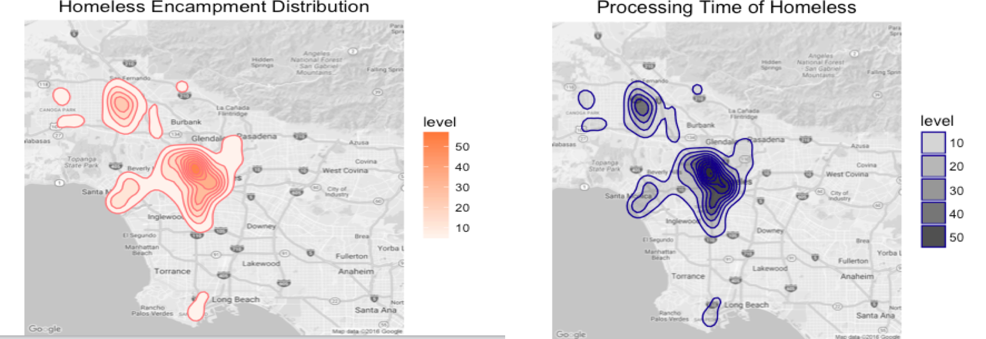

Homeless encampment occur primarily in central LA based on police precinct

There is a performance gap in the Southern and Western Regions – low frequency but high average processing time

The Valley is performing well – high frequency but low average processing time

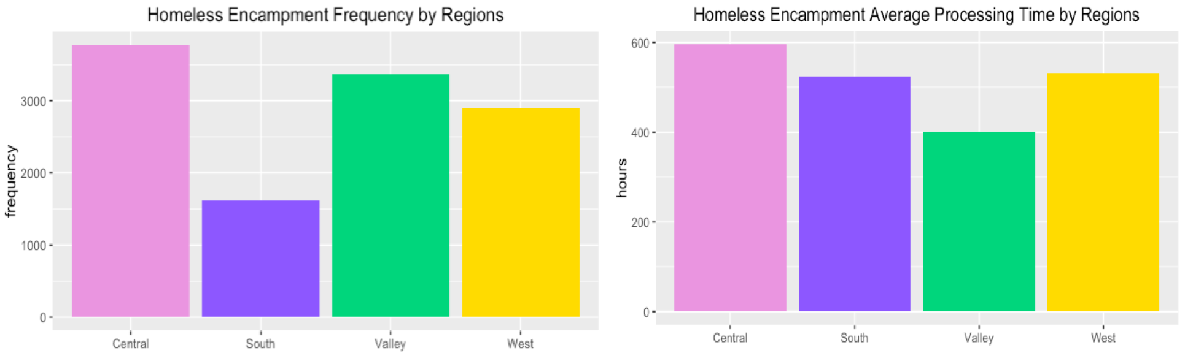

# **Appendix**

## **Data Overview**

We first did some cross-variable data visualizations to get the big picture of our data points.

### ***Request Type, Frequency vs Average Processing Hours***

As shown in the below graph, Bulky Items, Graffiti Removal and Metal/Household Appliances are three main service types that are most frequently requested by citizens. Bulky item requests comprise of the majority of requests for 311 - 44%. And the difference of frequency requested is huge from service to service.

For the processing time line graph, Homeless Encampment and Feedback take longer time than others to complete.

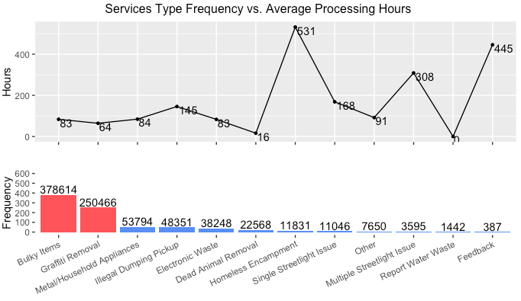

Then, we broke down the service type by month. Bulky Items peaks at August, then gradually decreases. Graffiti Removal increases through Jan to March, and then seems stable around 30000. All others’ demand seems flat in the graph due to lower total number of service requests.

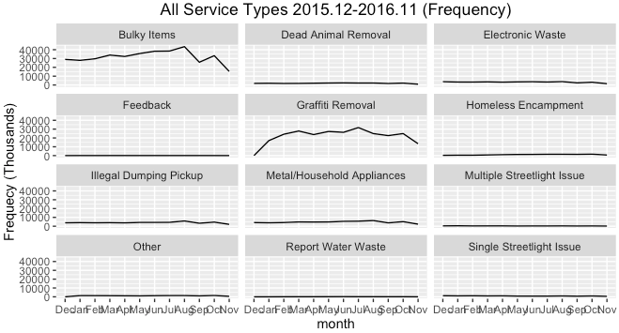

### ***Request Source, Frequency vs Average Processing Hours***

The most popular input channels are Phone Call, Mobile App, and Driver Self Report. The reason behind this may be shorter service processing time. We can see that Phone call and Driver Self Report method are in the shorter processing time level. Writing letter to make a request takes the longest processing time, which reason might be the longer mailing time than other methods. And surprisingly, phone call shows higher efficiency than the Mobile App. Probably because the City of Los Angeles allocate more human resources on dealing with phone calls, which make this channel more efficient.

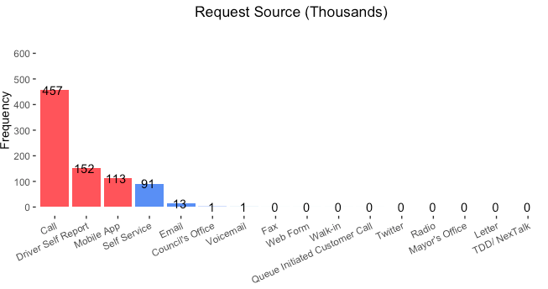

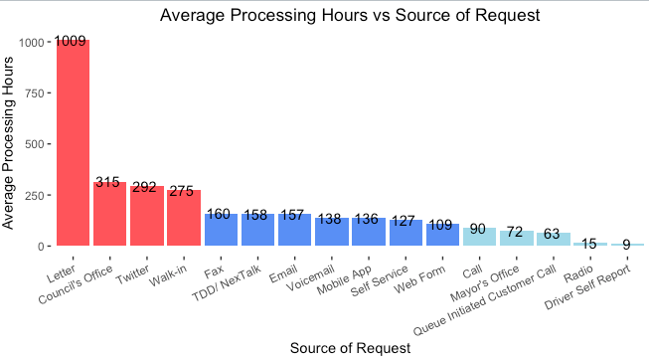

The next bar chart shows top 5 services distributed by top 5 input channel. We can see that except the Graffiti Removal which is mainly through Driver Self Report channel, most requests are made through Phone calls.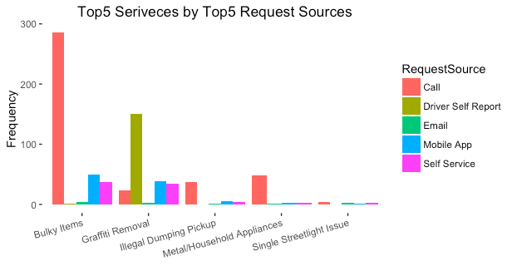

### ***Request by Departments, Frequency***

Because some of service request types have a relative small number of total requests, which is not visible in the graph, we standardized the data to dig in more insights. According to the graph, we can see that the frequency of Bulky Items and Graffiti Removal requests are above average frequency of all types of request. This means that Bulky Items and Graffiti Removal have much higher volume than other services, exceeding two times standard deviation.

And BOS Department handle more kinds of services than others. Combined with the following graph showing that BOS Department’s average processing time is below average. We can see that BOS Department is quite efficient. It deals with more types of service using less processing time.

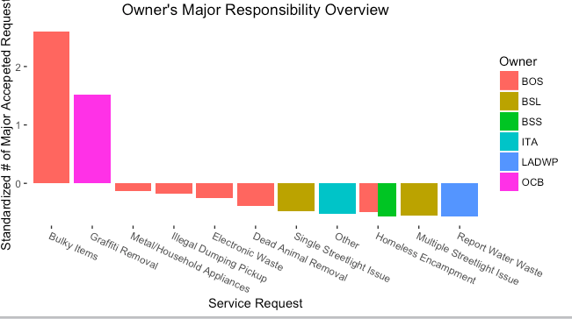

We can see that even though the BOS Department deal with most of the requests, the average service processing time is 64 hours. While, BSS Department needs the longest processing time, 709 hours, to do a relative smaller number of total request times. This is not because that BSS Department is less efficient compared with other departments. From the following graphs we can see that in fact BSS’s main job is Homeless Encampment; and Homeless Encampment takes the longest processing hours than other service types.

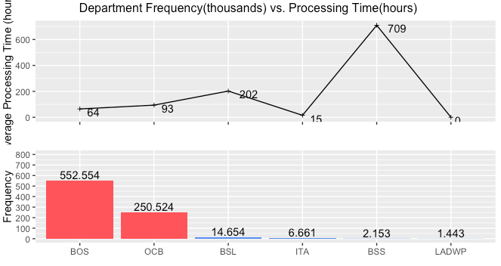

The following line chart shows standardized average processing time by department. It tells us LADWP Department spends less time to complete the service. The below bar chart shows the standardized frequency of service requests by departments. What’s worth noticing is that OCB Department completes second high volume requests with below average processing time.

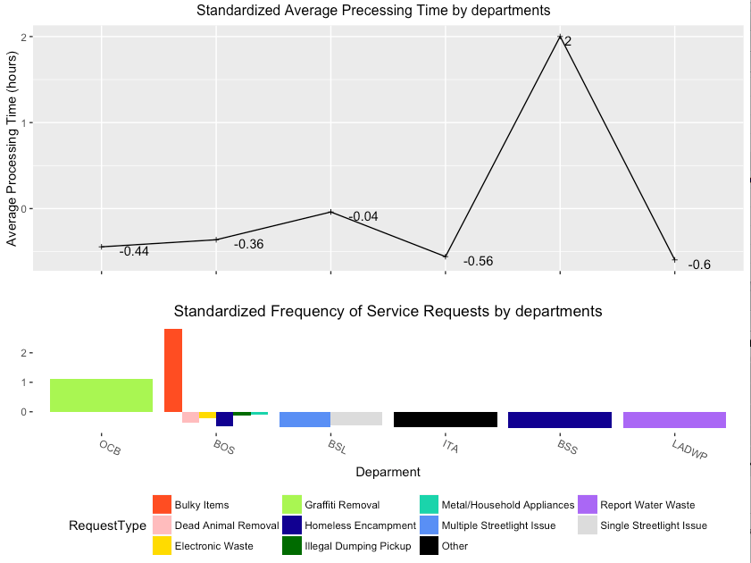

### ***Geographical Breakdown***

311 provides a wide range of services throughout Los Angeles, Long Beach, and the Valley.

Services are primarily centered in Downtown Hollywood, and South LA with some activity in the Valley; Downtown processing time appears to be longer.

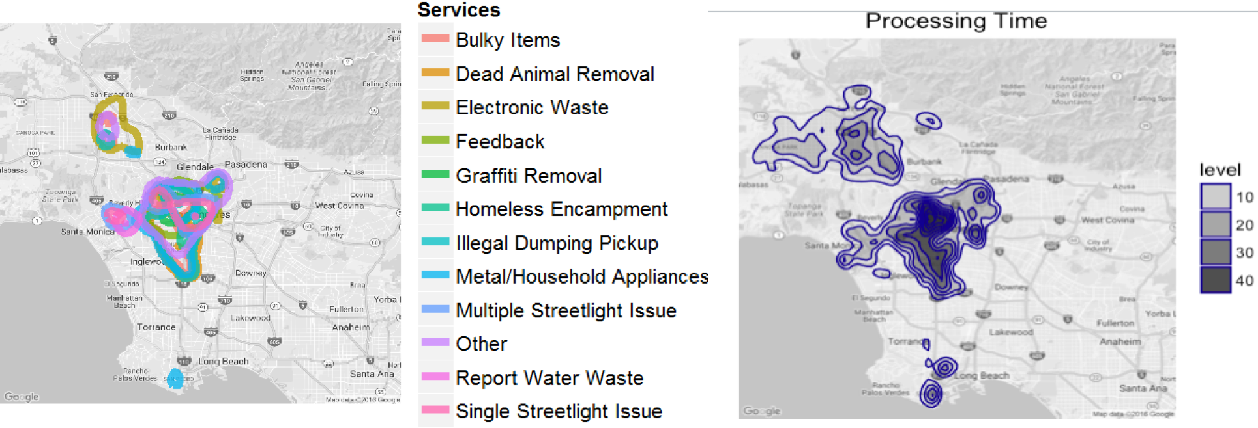

Certain services are delivered throughout Los Angeles, while others are isolated to one area. For example, Report Water Waste is mainly located around Hollywood area.

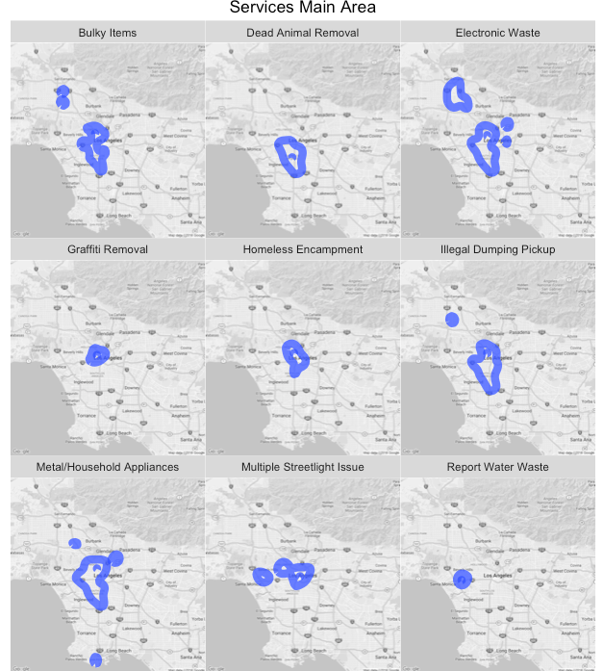

Processing time can range broadly despite frequency of service areas is central to specific areas.

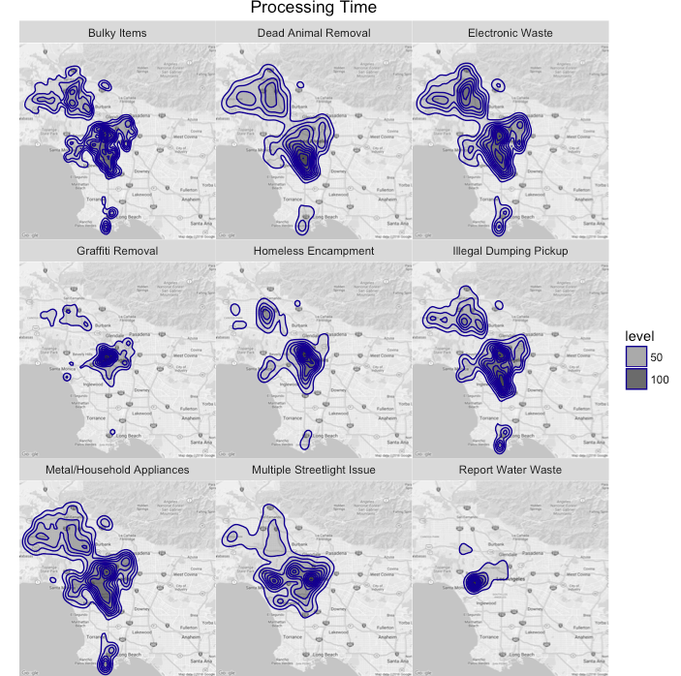

### ***Mobile App vs Phone Call***

To find out why people make more phone calls than using mobile app, we created following two graphs to compare the average processing time between Phone Call and Mobile App. We can see that generally Mobile App takes longer to process the service request than Phone Call, except for the feedback request and other request.

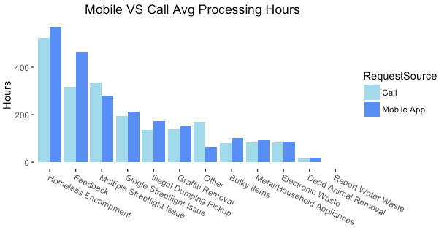

We then broke down deeper to see the efficiency of different OS of mobile phones. iOS is generally more efficient than Android, but the difference is not very big. We infer that Android system has more versions and scales, so the development time for each Android sizes is less than iOS, which leads to the lower performance.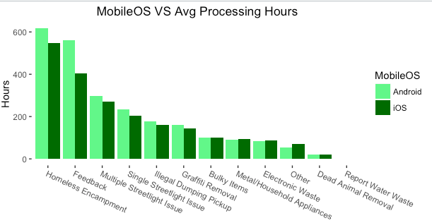

### ***Other Graphs***

